Data Sanitization

🧾 What Is Data Sanitization?
# Source: AI Source: Provided by: [Data Path: Persons Table -> ID Column: 1, Name_En Column: Motasem Essam] -> From: [ChatGPT] on [2/12/2026]
Data sanitization is the process of cleaning user input to remove or neutralize harmful or unwanted content before using or displaying it.
👉 It makes data safe.

✅ Simple Definition:
# Source: AI Source: Provided by: [Data Path: Persons Table -> ID Column: 1, Name_En Column: Motasem Essam] -> From: [ChatGPT] on [2/12/2026]
Data sanitization is modifying input to prevent security risks and ensure safe usage.

🧠 Real-Life Analogy:
# Source: AI Source: Provided by: [Data Path: Persons Table -> ID Column: 1, Name_En Column: Motasem Essam] -> From: [ChatGPT] on [2/12/2026]
Think of it like washing fruits before eating 🍎:
● You don’t reject the fruit (like validation)
● You clean it to make it safe
👉 Sanitization = cleaning, not rejecting

🔁 How Data Sanitization Works
# Source: AI Source: Provided by: [Data Path: Persons Table -> ID Column: 1, Name_En Column: Motasem Essam] -> From: [ChatGPT] on [2/12/2026]
- 👤 User submits input
- 📥 Server receives data
- 🧹 Clean the data (remove harmful parts)
- ✅ Safe data is stored or displayed

⚠️ Why Sanitization Is Important
# Source: AI Source: Provided by: [Data Path: Persons Table -> ID Column: 1, Name_En Column: Motasem Essam] -> From: [ChatGPT] on [2/12/2026]
Without sanitization:
❌ Malicious scripts can run
❌ Website can be hacked
❌ Data can be corrupted
👉 It protects against attacks

🛡️ Common Attacks Prevented

🔹 1. XSS (Cross-Site Scripting)
# Source: AI Source: Provided by: [Data Path: Persons Table -> ID Column: 1, Name_En Column: Motasem Essam] -> From: [ChatGPT] on [2/12/2026]
👉 Prevent injecting JavaScript into pages

🔹 2. SQL Injection
# Source: AI Source: Provided by: [Data Path: Persons Table -> ID Column: 1, Name_En Column: Motasem Essam] -> From: [ChatGPT] on [2/12/2026]
👉 Prevent harmful SQL queries

🔹 3. HTML Injection
# Source: AI Source: Provided by: [Data Path: Persons Table -> ID Column: 1, Name_En Column: Motasem Essam] -> From: [ChatGPT] on [2/12/2026]
👉 Prevent unwanted HTML rendering

🔍 Common Sanitization Techniques

🔹 Escape Special Characters
# Source: AI Source: Provided by: [Data Path: Persons Table -> ID Column: 1, Name_En Column: Motasem Essam] -> From: [ChatGPT] on [2/12/2026]
Convert special characters to safe format
👉 Example:
<script> → &lt;script&gt;

🔹 Remove Tags
# Source: AI Source: Provided by: [Data Path: Persons Table -> ID Column: 1, Name_En Column: Motasem Essam] -> From: [ChatGPT] on [2/12/2026]
Strip HTML/JS tags

🔹 Trim Input
# Source: AI Source: Provided by: [Data Path: Persons Table -> ID Column: 1, Name_En Column: Motasem Essam] -> From: [ChatGPT] on [2/12/2026]
Remove extra spaces

🔹 Encode Output
# Source: AI Source: Provided by: [Data Path: Persons Table -> ID Column: 1, Name_En Column: Motasem Essam] -> From: [ChatGPT] on [2/12/2026]
Convert data before displaying

💻 Simple PHP Example
# Source: AI Source: Provided by: [Data Path: Persons Table -> ID Column: 1, Name_En Column: Motasem Essam] -> From: [ChatGPT] on [2/12/2026]
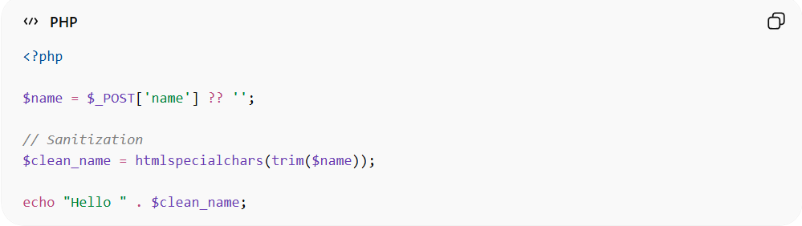
<?php

$name = $_POST['name'] ?? '';

// Sanitization
$clean_name = htmlspecialchars(trim($name));

echo "Hello " . $clean_name;
● trim() removes extra spaces
● htmlspecialchars() prevents XSS
● Output becomes safe

📦 Example (Before vs After)
# Source: AI Source: Provided by: [Data Path: Persons Table -> ID Column: 1, Name_En Column: Motasem Essam] -> From: [ChatGPT] on [2/12/2026]
Input:
<script>alert('Hacked')</script>
After sanitization:
&lt;script&gt;alert('Hacked')&lt;/script&gt;
👉 Script will NOT execute

⚔️ Validation vs Sanitization
# Source: AI Source: Provided by: [Data Path: Persons Table -> ID Column: 1, Name_En Column: Motasem Essam] -> From: [ChatGPT] on [2/12/2026]
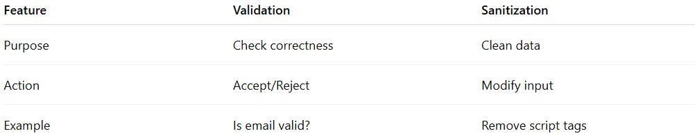
Feature | Validation | Sanitization
Purpose | Check correctness | Clean data
Action | Accept/Reject | Modify input
Example | Is email valid? | Remove script tags

🔗 Relation to Other Topics
# Source: AI Source: Provided by: [Data Path: Persons Table -> ID Column: 1, Name_En Column: Motasem Essam] -> From: [ChatGPT] on [2/12/2026]
● Data Input Handling → includes sanitization
● Data Validation → happens before sanitization
● Security → sanitization prevents attacks
● APIs → sanitize incoming data

⚙️ Best Practices
# Source: AI Source: Provided by: [Data Path: Persons Table -> ID Column: 1, Name_En Column: Motasem Essam] -> From: [ChatGPT] on [2/12/2026]
✅ Always sanitize before output
✅ Use built-in functions (htmlspecialchars)
✅ Combine with validation
✅ Never trust user input

🎯 Key Idea
# Source: AI Source: Provided by: [Data Path: Persons Table -> ID Column: 1, Name_En Column: Motasem Essam] -> From: [ChatGPT] on [2/12/2026]
👉 Sanitization = clean the data
👉 Makes input safe for use

🎓 Final Mental Model
# Source: AI Source: Provided by: [Data Path: Persons Table -> ID Column: 1, Name_En Column: Motasem Essam] -> From: [ChatGPT] on [2/12/2026]
● Input = may be dangerous
● Validation = check it
● Sanitization = clean it
👉 Clean data = secure system 🔐

